There are two different sensors currently in use. One indirectly measures the water content through correlations with soil properties such as permittivity, electrical resistance, dielectric properties of the soil, or electromagnetic properties. The second option allows for directly or indirectly measuring the soil's suction or negative pore water pressure. Those include tensiometers and electric resistance sensors, among others.
This synthesis aims to document the current State DOT practices for measuring and monitoring moisture and pore water pressure for pavement embankments, slopes, foundations, bridge abutments, retaining structures, and groundwater table depth. The synthesis focuses on State DOT practices related to the instrumentation and type of testing, infrastructure moisture and pore water pressure measurement practices, and planning and implementation of moisture and pore water pressure measurement. This information includes:
- Instrumentation and type of testing, including agency roles for testing and monitoring moisture and pore water pressure, and moisture and pore water pressure testing methods and types.
- Infrastructure moisture and pore water pressure measurement practices, which include collecting data on the type of infrastructure that agencies monitor for moisture content and pore water pressure, frequency of the collected data, the different phases in the engineering process that are monitored, extended long-term moisture monitoring, moisture-sensitive soils and monitoring programs, usage of sensing techniques, and factors that affect the decision- making process for partaking moisture measurements.
- Planning and implementation of moisture and pore water pressure measurements, which includes obstacles facing the agency during measurements, the agency's prioritization for infrastructures monitoring, moisture database collection and management, design manual or specifications for moisture measurements, and helpful activities to improve the measurement.

Synthesis Methodology
A literature review provided the initial understanding of the past and current states of the art and practice related to measuring and monitoring moisture and pore water pressure. The review was limited to the practice exerted by some DOT agencies.
A survey was designed to capture the current State DOT practices of measuring and controlling moisture and pore water pressure with the guidance of the synthesis panel. The survey was developed with the help of the available literature and earlier communication with the NCHRP synthesis panel. The survey was divided into three subcategories: instrumentation and type of testing, infrastructure moisture and pore water pressure measurement practices, and planning and implementation of moisture and pore water pressure measurement. After the final draft of the survey was authorized, the survey was sent to members of the geotechnical and geologist professional groups of the 50 State DOTs. The distributed survey was forwarded to individuals with knowledge of measuring and monitoring moisture and pore
water pressure within their organizations, particularly those from the geotechnical groups. The complete version of the survey is shown in Appendix A.

The response rate was 80%, with 40 responses from different State DOTs received from the survey participants. The results of individual questions of the distributed survey are shown in Appendix B.

After analyzing survey responses, selected DOTs were contacted to gather additional information on their practices. Interviews were conducted by phone with geotechnical engineers from three State DOTs geotechnical engineers who measure and monitor moisture and positive or negative pore water pressure. The interview summaries are presented in Chapter 4.

Report Organization
This synthesis report documents the current practices of State DOTs regarding measuring and monitoring moisture and pore water pressure. The report is organized as follows:
  - Summary
  - Chapter 1: Introduction
  - Chapter 2: Literature Review
  - Chapter 3: Survey Results
  - Chapter 4: Case Examples of State DOTs Practices
  - Chapter 5: Summary of Findings
  - Appendix A: Survey Questionnaire for State DOTs
  - Appendix B: Results of the Survey Questionnaire
  - Appendix C: Bibliography

CHAPTER 2

Literature Review
Soil moisture strongly influences the engineering, agricultural, ecological, geological, hydrological, and biological characteristics of soil mass (Lekshmi et al., 2014). The mechanical properties of soil, such as strength, stiffness, density, compatibility, consistency, shrink-swelling behaviors, and soil suction, are highly dependent on soil moisture (Fredlund, 2006; Lekshmi et al., 2014; Han and Vanapalli, 2017). This section presents a literature review comprising the concept and definition of soil moisture, conventional and modern instrumentation for moisture measurement, and soil’s engineering performance affected by moisture variation. In addition, selected background research on the state of practice in the State departments of transportation related to moisture and pore water pressure measurement techniques is presented. This information was gathered from published websites and manuals accessible to the public, and it is not intended to be a comprehensive review of manuals available on all DOT websites.

Soil Moisture
Soil packing in natural occurrence consists of space occupied by solid particles and void space between particles. The void space may be occupied by air or water. Generally, the soil packing has a three-phase system (e.g., solid, water, and air). The moisture of the soil mass can be determined by volume (volumetric) or weight (gravimetric). The soil is considered dry when no water is in the voids and unsaturated when water and air occupy the voids. On the other hand, the soil is considered saturated when the voids are fully occupied by water (Das and Sobhan, 2016). Soil moisture migration results from hydrostatic pressure differences or gradients, capillary tension, osmotic pressure, temperature gradients, and chemical potentials. The moisture mass can migrate through the soil in either a liquid state, a vapor state, or a combination of both states (Marks et al., 1968).
Fredlund et al. (2012) define the boundary of saturated and unsaturated zones in soil strata. The saturated soil zone is any soil under the groundwater table where the water fills the void, and the air dissolves. In contrast, the unsaturated soil zone is any soil that is located above the groundwater table, which is characterized by three different zones (e.g., capillary zone, two phases zone, and dry zone) based on the continuity of air and water phases, as shown in Figure
1. The unsaturated or vadose zone thickness is mainly controlled by the depth of the groundwater table, which is influenced by the ground surface climatic condition.
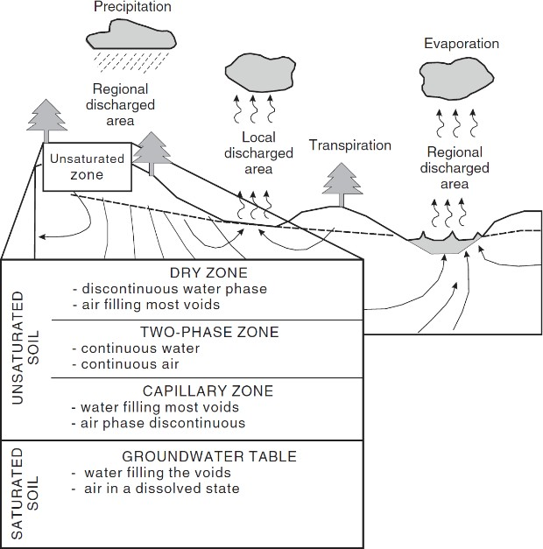

Figure 1. Illustration of the saturated and unsaturated soil zones on a regional and local basis (Fredlund et al., 2012).

In the unsaturated soil zone, the pore water pressure becomes negative, and due to hydraulic, thermal, and other gradients, this zone allows for the continuous movement of water from the atmosphere to the groundwater, tending to equilibrium conditions. The negative pore water pressure (soil suction) equals zero at the groundwater table depth since the voids are filled by water (saturated zone), and once the air starts filling the voids, the negative pore water pressure increases as the soil becomes drier. The relationship between the amount of moisture the soil can retain at a particular soil suction value can be represented by the soil water characteristic curve (SWCC) or soil water retention curve (SWRC). Consequently, the change in soil suction, which is driven by changes in soil moisture and vice-versa, can result in the adverse influence of water on the shear strength, stiffness, and volume change of moisture-sensitive soil such as expansive, collapsible, and residual soils (Fredlund, 2006).
Conventional measurement of soil moisture content uses techniques where the amount of water in the soil specimen is computed after the water mass is removed by evaporation (Lekshmi et al., 2014). These techniques include thermo-gravimetric (oven-dry) and calcium carbide methods (Speedy test). More modern moisture measurement methods include techniques where the soil moisture is indirectly obtained by measuring the soil's electrical, thermal conductivity, and resistivity properties. Table 1 summarizes soil moisture content measurement methods, characterized by laboratory or in-situ application, the principle behind the technique, a brief description and the standard or reference for each method.
In unsaturated soils, negative pore water pressure (soil potential or soil suction) is measured directly through tensiometers or indirectly through hygrometric techniques and soil thermal conductivity. On the other hand, for saturated soil, the positive pore water pressure (piezometric pressure) is measured through piezometric techniques. Table 2 presents a summary of the pore water pressure (soil suction or piezometric) measurement methods, including the principle behind
the measurement, range of measurement, applications, a brief description of the technique, limitations, and examples of available brands.

